# MEMORANDUM OF UNDERSTANDING?ui=2&ik=e08d64f739&view=att&th=14717d0e55bf5cce&attid=0.jpg

**Standard Response Protocol (SRP)**

**Memorandum of Understanding (MOU) with**

**The “I Love U Guys” Foundation (The Foundation)**

**Program Description:** The Standard Response Protocol (SRP) is a classroom response based on four actions. When communicating these actions, the action is labeled with a “Term of Art” and is then followed by a Directive. Execution of the action is performed by active participants, including students, staff, teachers and first responders.

The “Term of Art” **Lockout** is followed by the Directive **“Secure the Perimeter”.** The action associated with Lockoutis to bring participants into the School Building and secures the building’s outside perimeter by locking appropriate windows, doors or other access points.

The “Term of Art” **Lockdown** is followed by the Directive **“Locks, Lights, Out of Sight”** The action associated with Lockdown is to secure individual classroom doors, move away from inside corridor line of sight and maintain silence until first responders release the room.

The “Term of Art” **Evacuate** is followed by the Directive **“To a Location”** (Where Location is announced.) The action associated with Evacuate is to move students and staff from one location to another.

The “Term of Art” **Shelter** is followed by the Directive **“Type and Method”** (Where Type is one of the following: For Tornado, For Hazmat, For Bomb. Method is one of the following: And seal, In Silence, Drop, Cover and Hold.) The action associated with Shelter is dependent on the stated Type and Method.

**Communication:** Communication between School and The Foundation may be accomplished through written correspondence delivered by the US Postal Service or other private carriers. Communication may also be accomplished through electronic means utilizing electronic mail, facsimile or other electronic text communications.

**Purpose:** By standardizing vocabulary, all stakeholders can understand the response and status of the event. For students, this provides continuity of expectations and actions throughout their educational career. For teachers and staff this becomes a simpler process to train and drill. For first responders, the common vocabulary and protocols establish a greater predictability that persists through the duration of an incident. Parents can easily understand the practices and can reinforce the protocol. Additionally, this protocol enables rapid response determination when an unforeseen event occurs.

**Agreement by School:**

1. School agrees to incorporate SRP in the official, existing, written safety plans of all schools in district, either in the body or as an addendum or amendment.
2. School agrees to appoint an SRP Liaison who will act as the primary contact regarding communication with The Foundation and other department, district or agency SRP Liaisons.
3. School agrees to incorporate the SRP using the terms of art and the associated directives as defined in the Program Description.
4. School agrees to provide Law Enforcement Agencies having jurisdiction within the School District with notice of compliance with SRP terms of art and directives.
5. School agrees to provide Fire Departments having jurisdiction within the School District with notice of compliance with SRP terms of art and directives.
6. School agrees to provide Emergency Medical Services having jurisdiction within the School District with notice of compliance with SRP terms of art and directives.
7. School agrees to provide County and/or City Emergency Managers having jurisdiction within the School District with notice of compliance with SRP terms of art and directives.
8. School agrees to provide students with training on the SRP at least once per school year.
9. School agrees to provide staff with training on the SRP at least once per school year.
10. School agrees to drill each action.
11. School agrees to provide parents with either printed material or notice of online availability of material at http://www.iloveuguys.org.
12. School is responsible for physical material production of any online resources provided by The Foundation. The District is not required to utilize printing services provided by The Foundation for production of support materials.
13. School will provide The Foundation with 1 representative copy of printed or electronic materials produced from online materials provided by The Foundation.
14. School will engage in a best effort to provide The Foundation with contact information for other agencies, departments, services, schools participating with the School District regarding the SRP.

**Agreement by The “I Love U Guys” Foundation:**

1. The Foundation agrees to host training materials on the Website available publicly at the Uniform Resource Locator http://iloveuguys.org
2. The Foundation agrees to provide training and support materials online to School District staff, students, teachers and parents at no charge to School.
3. The Foundation agrees to provide training and support materials online to Law Enforcement Agencies at no charge to the Agency.
4. The Foundation agrees to provide training and support materials online to Fire Departments at no charge to the Department.
5. The Foundation agrees to provide training and support materials online to Emergency Medical Services at no charge to the Service.
6. The Foundation agrees to provide training and support materials online to County and/or City Emergency Managers at no charge to the County or City.
7. The Foundation offers brokered printing services for production of printed support materials. The Foundation has no expectations that School will utilize The Foundation’s brokered printing services for production of printed support materials.
8. The Foundation provides hands on training sessions for a suggested donation, in locations around the United States. School is under no obligation to attend these training sessions.
9. The Foundation will notify the SRP Liaison via Written or Electronic communications in the event of new or updated materials available on the Website.
10. The Foundation will maintain a record of all Written or Electronic communication with the School District.

**Memorandum Term:** This Memorandum is effective until terminated, for all schools in the School District.

**Termination:** School may terminate this Memorandum of Understanding via Written or Electronic notification at any time. Upon termination School will cease use of any materials provided by The Foundation.

**Name of School Mail to: The “I Love U Guys” Foundation**

**___________________________________________** PO Box 1230, Bailey, Colorado 80421

Address ____________________________________ Email to: MOU@iloveuguys.org

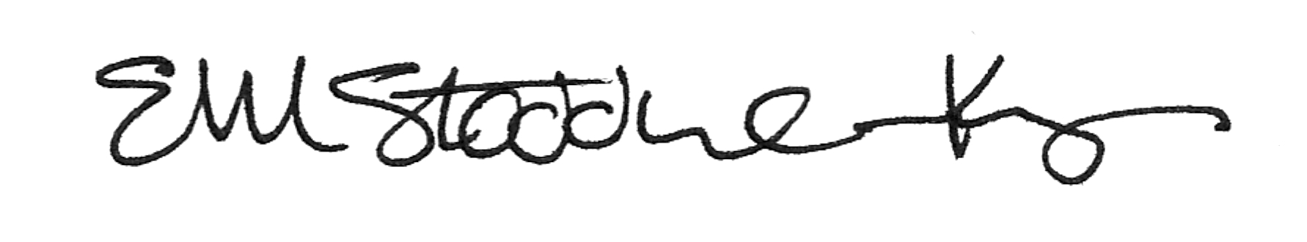___________________________________________

___________________________________________ _____________________________________

Representative Signature Representative Signature

___________________________________________ Ellen Stoddard-Keyes

Print Name Print Name

___________________________________________ President, Board of Directors

Title Title

Date: ______________________________________ Date: March 19, 2018

Contact information: ____________________________________________________________________